Methods

This scoping review was performed following the ROSES standards of reporting for scoping and systematic reviews [1]. While the protocol was not pre-published, we followed the ROSES guidelines with the objective of ensuring transparency and maximizing the reproducibility of the search performed.

Selection criteria

The inclusion and exclusion criteria for the screening were identified and recorded before initiating database searches. We included primary literature that sought to determine the effects of a factor on a quantitative measurement of sentinel behavior (e.g., frequency, duration, number of bouts, etc.). We only included articles that tested sentinel behavior in terrestrial or avian vertebrates. We rejected articles dated earlier than 1970, as the definition of sentinel behavior in older articles was often nebulous and not consistent with the definition. Theoretical or review articles were excluded. Articles not written in English were rejected unless a translated copy could be obtained. An additional exclusion criterion was added during full-text screening, and articles on mixed-species flocks were excluded.

Search strategy

A preliminary search was performed in Web of Science and Google Scholar to find relevant articles and generated a list of exemplar articles. This list was subsequently used to test the comprehensiveness of the final search strategy and screening. Common keywords in the exemplar articles were compiled and used to develop the search string. The search string used to search for articles was "Sentinel AND Behavio*". We filtered the articles by removing articles in fields unrelated to behavior (e.g., sleep, remote sensing). On Nov. 1st, 2022, we searched through Web of Science Core, Current Contents Connect, Zoological Records, SciELO Citation Index, KCI-Korean Journal Database, BIOSIS Citation Index, Data Citation Index, and exported the list of search results from Web of Science. The full search string is provided in Table 1.

Following the search and screening of articles, Elicit was searched using the factors identified during the full-text screening and synthesis to obtain any articles not present in the databases searched [2].

Data collection & analysis

Title and abstract were screened in triplicate using the "Metagear" package in R [3] by A.P following the inclusion and exclusion criteria. Full texts of articles that passed the initial screening were sought, then screened. Measurements of sentinel behavior and factors tested by the articles were recorded, as well as the model species. A narrative synthesis of the different factors identified in the literature was written in Obsidian, making links between articles with similar themes and factors. We kept a record of articles that defined sentinel behavior, and if that definition included coordination as a defining feature as proposed by Bednekoff (2015, [4]).

Table 1: Search string used on Nov. 1st, 2022

|  |  |
| --- | --- |
| Element | String |
| Topic | sentinel AND Behavio* |
| Language | “ENGLISH” |
| Subject | “BEHAVIORAL SCIENCES” |
| NOT Subject | "HEALTH CARE SCIENCES SERVICES" OR "PEDIATRICS" OR "PHARMACOLOGY PHARMACY" OR "MARINE FRESHWATER BIOLOGY" OR "GENERAL INTERNAL MEDICINE" OR "METEOROLOGY ATMOSPHERIC SCIENCES" OR "SUBSTANCE ABUSE" OR "CRIMINOLOGY PENOLOGY" OR "RADIOLOGY NUCLEAR MEDICINE MEDICAL IMAGING" OR "SURGERY" OR "MEDICAL LABORATORY TECHNOLOGY" OR "PUBLIC ENVIRONMENTAL OCCUPATIONAL HEALTH" OR "WOMEN APOS S STUDIES" OR "GEOCHEMISTRY GEOPHYSICS" OR "RESEARCH EXPERIMENTAL MEDICINE" OR "IMAGING SCIENCE PHOTOGRAPHIC TECHNOLOGY" OR "EDUCATION EDUCATIONAL RESEARCH" OR "BUSINESS ECONOMICS" OR "BIOTECHNOLOGY APPLIED MICROBIOLOGY" |

Results

We included 43 articles in the review. The articles collected during the database search, as well as the number of studies excluded at each stage of the review and the reasons for exclusion can be found in Fig. 1. A comprehensive list of articles and reasons can be found in the supplemental materials.

Due to the number of different species used, experimental designs, and measurements, we were unable to perform a meta-analysis. We did not assess the validity of each study, though 10 articles were removed during the full-text screening phase for using a vague or inconsistent definition of ‘sentinel behavior’. We excluded such articles since it was uncertain if it was sentinel behavior or some other form of vigilance, for example synchronized vigilance.

The factors assessed by the articles retained ranged from internal to social and environmental factors.

29 articles retained conducted studies on sentinel behavior on avian species, with most studies being performed on *Argya* (6), *Turdoides* (5), and *Aphelocoma* (5) species. The remaining studies were conducted on various other species such as red-winged blackbirds, finches, and cranes. 14 studies were conducted on mammal species, with the majority being performed on meerkats (*Suricata suricatta,* 7), and dwarf mongoose (*Helogale parvula,* 5). The other studies performed on mammals studies sentinel behavior in primate species.

To follow up on Bednekoff’s 2015 review on sentinel behavior, we recorded the number of studies that explicitly mention ‘coordination’ as a characteristic element of sentinel behavior. Out of 43, 14 articles fit this criterion, with an upward trend being observed in the 2017-2021 period. The remaining articles did not mention coordination as a defining feature of sentinel behavior and the

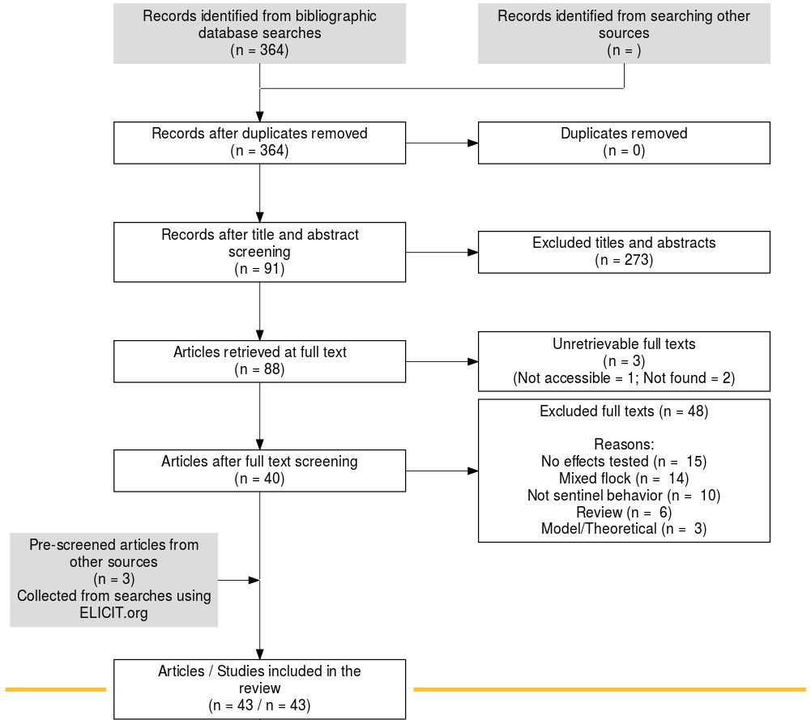

Figure 1: ROSES Flow diagram showing literature sources and inclusion/exclusion process

Table 2: Number of articles retained by the search strategy

The number of articles that mention coordination as a defining feature are identified in the third column.